US HEALTHCARE ANALYSIS POWER BI DASHBOARD:

**Objective:**

The primary objective of this Power BI project is to conduct a comprehensive analysis of the healthcare industry. By leveraging interactive visualizations and dynamic filters, the dashboard aims to provide detailed insights into various facets of healthcare, including patient demographics, expenses, and treatment trends. The overarching goal is to empower stakeholders with actionable information essential for strategic decision-making in healthcare management and policy formulation. Through the exploration of diverse datasets and the presentation of insights in a user-friendly manner, this project seeks to facilitate a deeper understanding of the healthcare landscape and enable stakeholders to make informed decisions that drive positive outcomes and improve the overall quality of patient care.

**DATA DITIONARY:**

|  |  |  |
| --- | --- | --- |
| **Fact-Table** | **Column** | **Definition** |
| FactTable (Primary Key) | FactTablePK | Unique identifier (Primary Key) for the fact table. |
| FactTable (Foreign Key) and dimPatient (Primary Key) | dimPatientPK | Unique identifier that joins the patient table to the fact table |
| FactTable (Foreign Key) and dimPhysician (Primary Key) | dimPhysicianPK | Unique identifier that joins the physician table to the fact table |
| FactTable (Foreign Key) and dimDate | dimDatePostPK | Text formatted date that specifies the day the transaction was posted to the billing system |
| FactTable (Foreign Key) | dimDateServicePK | Text formatted date that specifies the day the patient was seen by the physician |
| FactTable (Foreign Key) and dimCptCode | dimCPTCodePK | Unique identifier that joins the CPT table to the fact table |
| FactTable (Foreign Key) and dimPayer | dimPayerPK | Unique identifier that joins the payer table to the fact table |
| FactTable (Foreign Key) and dimTransaction | dimTransactionPK | Unique identifier that joins the transaction table to the fact table |
| FactTable (Foreign Key) and dimLocation | dimLocationPK | Unique identifier that joins the location table to the fact table |
| FactTable and dimPatient | PatientNumber | Unique Patient identifier. This is often times called a Medical Record Number (MRN) |
| FactTable and dimDiagnosisCodePK | dimDiagnosisCodePK | Unique identifier that joins the patient table to the fact table |
| FactTable | CPTUnits | The number of times the CPT Code has been performed. |
| FactTable | GrossCharge | The gross charge for the CPT Code. This includes the contractual adjustment |
| FactTable | Payment | Payment received from payer and patient |
| FactTable | Adjustment | Any dollars from the gross charge that will not be collected |
| FactTable | AR | Outstanding accounts receivable that have yet to be collected or written off. |
| FactTable and dimPatient | PatientNumber | Unique Patient identifier. This is often times called a Medical Record Number (MRN) |

|  |  |  |
| --- | --- | --- |
| **Patient-Table** | **Column** | **Definition** |

**DATA DITIONARY:**

|  |  |  |
| --- | --- | --- |
| dimPatient | FirstName | First Name of the patient |
| dimPatient | LastName | Last Name of the patient |
| dimPatient | Email | Patients email address |
| dimPatient | PatientGender | Gender/Sex of the patient |
| dimPatient | PatientAge | Age of the Patient |
| dimPatient | PatientHeight(in cms) | Height of Patient in centimeters |
| dimPatient | Year of Birth | Year of Birth of Patient |
| dimPatient | Month | Month of Birth of Patient |
| dimPatient | Day | Day of Birth of Patient |
| dimPatient | BloodGroup | BloodGroup of the Patient |
| dimPatient | Tobacco | Patient consumes Tobacco or not as per the medical records |
| dimPatient | Alcohol | Patient consumes Alcohol or not as per the medical records |
| dimPatient | Exercise | Patient does regular exercise or not by records |
| dimPatient | Diet | Patient follows strict diet or not as per medical records |
| dimPatient | Ethinicity | Ethinicity of the Patient as per medical records |
| dimPatient | Zip Codes | Zip Codes of the place of resident as per medical records |
| dimPatient | State Code | State Code that the patient lives in |
| dimPatient | City | City that the patient lives in |
| dimPatient | State | State that the patient lives in |
| dimPatient | Region | Region ofPatient's residence |
|  |  |  |
|  |  |  |
|  |  |  |
|  |  |  |

**DATA DITIONARY:**

|  |  |  |
| --- | --- | --- |
| **Speciality-Table** | **Column** | **Definition** |

|  |  |  |
| --- | --- | --- |
| dimSpeciality | SpecialityCode | Two-digit specialty code that corresponds to the specialty type declared by the Provider at the time of enrollment in the form. |
| dimSpeciality | ProviderSpecialty | Provide's Speciality |
| dimSpeciality | SpecialityType | Type of Provide's Speciality |
| dimSpeciality | SpecialityDesc | Description of the speciality |

|  |  |  |
| --- | --- | --- |
| **Transaction-Table** | **Column** | **Definition** |

|  |  |  |
| --- | --- | --- |
| dim Transaction | TransactionType | Clarifies whether the transaction was a charge, payment, adjustment, etc. |
| dimTransaction | Transaction | Specific transaction descriptions |
| dimTransaction | AdjustmentReason | Groups adjustments into operational reason groups |

|  |  |  |
| --- | --- | --- |
| **Physician-Table** | **Column** | **Definition** |

|  |  |  |
| --- | --- | --- |
| dimPhysician | ProviderNpi | Unique number assigned to each physician upon completion of medical school |
| dimPhysician | ProviderName | Physicians last name |
| dimPhysician | ProviderSpecialty | Area which the physician has specialized |
| dimPhysician | ProviderFTE | Physician time spent working on a weekly basis |
| dimPayer | PayerName | Payer category |
| dimLocation | LocationName | Field that specific where the service was rendered |

.

|  |  |  |
| --- | --- | --- |
| Table | Column | Definition |

|  |  |  |
| --- | --- | --- |
| dimDiagnosisCode | DiagnosisCode | Code assigned by the physician to specific the patients diagnosis |
| dimDiagnosisCode | DiagnosisCodeDescription | Description to clarify the diagnosis code |
| dimDiagnosisCode | DiagnosisCodeGroup | Group of Diagnosis Codes |
| dimCptCode | CptCode | Five-digit Current Procedural Terminology used to assign services rendered to the patient |
| dimCptCode | CptDesc | Specific CPT description |
| dimCptCode | CptGrouping | Groups the CPT codes into types of services |

|  |  |  |
| --- | --- | --- |
| Diagnose& CPT | Column | Definition |

|  |  |  |
| --- | --- | --- |
| **Date-Table** | **Column** | **Definition** |

|  |  |  |
| --- | --- | --- |
| dimDate | Date | Date format - either date service was rendered or date of a transaction |
| dimDate | Year | Year - either date service was rendered or date of a transaction |
| dimDate | Month | Month - either date service was rendered or date of a transaction |
| dimDate | MonthPeriod | YYYYMM Text Format - either date service was rendered or date of a transaction |
| dimDate | MonthYear | Month and Year - either date service was rendered or date of a transaction |
| dimDate | Day | Day of Month Number - either date service was rendered or date of a transaction |
| dimDate | DayName | Day of week name - either date service was rendered or date of a transaction |

**Key Features:**

**Comprehensive Analysis:** Provides a detailed examination of healthcare industry data, offering insights into various aspects such as patient demographics, expenses, and treatment trends.

**Interactive Visualizations:** Utilizes a variety of charts and graphs, including bar charts, pie charts, line charts, and area charts, to present data effectively and facilitate understanding.

**Dynamic Filters:** Enables users to explore data dynamically by applying filters based on parameters such as region, hospital, payer, provider, and patient demographics.

**Hospital Analysis:**

The Hospital Analysis section delves into various aspects of hospital performance, including accounts receivable, procedure volumes, and financial ratios. It highlights hospitals with the highest accounts receivable and insurance payment ratios, aiding in financial management strategies and resource allocation.

**Patient Analysis:**

The Patient Analysis section provides insights into patient demographics, habits, and treatment patterns. It examines trends inpatient admissions, demographics, and treatment modalities, helping healthcare providers tailor services to meet patient needs effectively.

**Executive Summary:**

The Executive Summary offers a concise overview of key metrics and trends in the healthcare industry. It includes insights into regional impact analysis, hospital performance evaluation, trend analysis, payer contribution assessment, and procedure dominance recognition.

**Payer Provider Analysis:**

The Payer Provider Analysis section evaluates the performance and trends of healthcare payers and providers. It examines expenses, reimbursement rates, and service utilization patterns, informing strategies to optimize financial performance and enhance patient care delivery.

**Stakeholder-Specific Views:** Tailors views for hospitals, payers, providers, and patients, allowing stakeholders to focus on insights relevant to their roles.

**Bookmarks:** Facilitates bookmarking of important insights within the dashboard, enhancing user experience and usability.

**Key Insights:**

**Regional Impact Analysis:** Identifies regions severely affected by the pandemic in terms of patient count and expenses, aiding in resource allocation and decision-making.

**Hospital Performance Evaluation**: Evaluates hospitals with the highest accounts receivable and insurance payment ratios, enabling targeted interventions to address financial challenges.

**Trend Analysis:** Analyses trends in healthcare expenses and patient admissions over time, helping stakeholders understand evolving patterns and plan accordingly.

**Payer Contribution Assessment:** Examines payers contributing significantly to medical expense dispersion, informing strategies to manage cost-sharing arrangements effectively.

**Procedure Dominance Recognition:** Recognizes hospitals dominating procedures performed during the pandemic, guiding efforts to optimize resource utilization and patient care delivery.

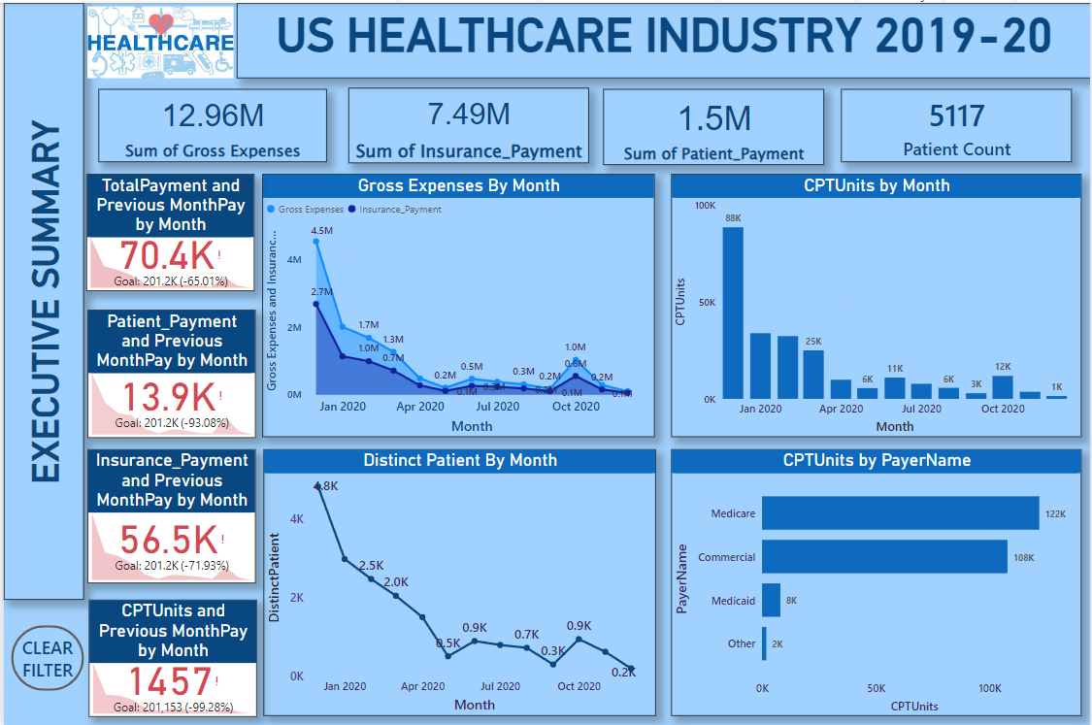**DASHBOARD:**

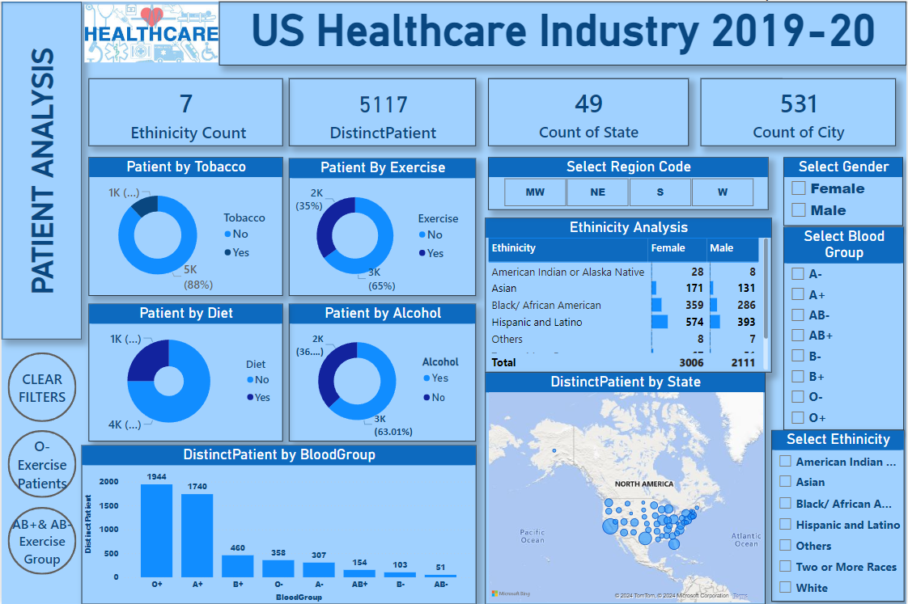

**Conclusion:**

This Power BI project provides an in-depth exploration of the healthcare landscape, covering patient demographics, hospital performance, and payer-provider interactions. Through interactive visualizations and adaptable filters, stakeholders can delve into diverse aspects of healthcare, uncovering trends and patterns crucial for decision-making. The dashboard's intuitive design, featuring charts, graphs, and tailored views, facilitates understanding and strategic planning for healthcare organizations and policymakers.

A key feature of this project is its ability to offer actionable insights through comprehensive data analysis. By examining regional impacts, evaluating hospital performance, and tracking trends over time, decision-makers can pinpoint areas of concern, allocate resources effectively, and devise targeted interventions to address challenges proactively. Additionally, insights into payer contributions and dominant procedures inform cost management strategies and resource allocation, ensuring financial sustainability and high-quality patient care.

In summary, this Power BI project is an indispensable tool for healthcare stakeholders, providing essential insights into the industry's intricate dynamics. Leveraging advanced analytics and visualization techniques, the dashboard empowers informed decision-making, strategic planning, and proactive management of COVID-19-related challenges. Going forward, its comprehensive analysis and actionable insights will play a pivotal role in driving positive outcomes, enhancing patient care, and optimizing operational efficiency across the healthcare ecosystem.